Putting Together a Moderation Presentation, Part 1: Using ACS

Video Transcript

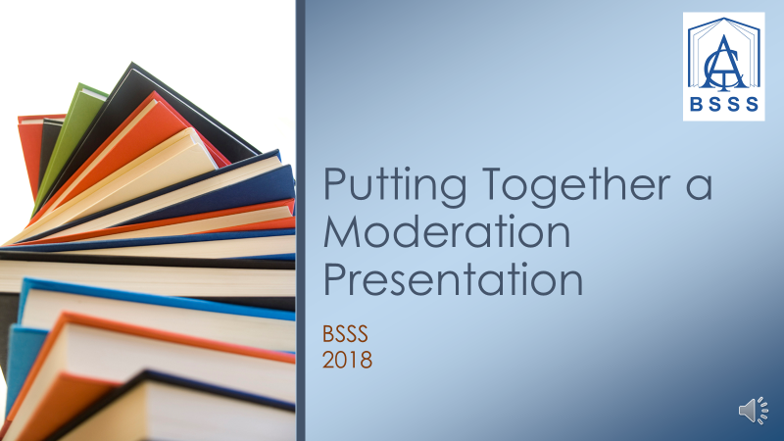

Welcome, Part 1: Using ACS
Welcome to the first of three videos about putting together a digital presentation for Moderation Day. The aim of these videos is to provide clear instructions on how to put together a successful presentation.

Preparing a Presentation in ACS
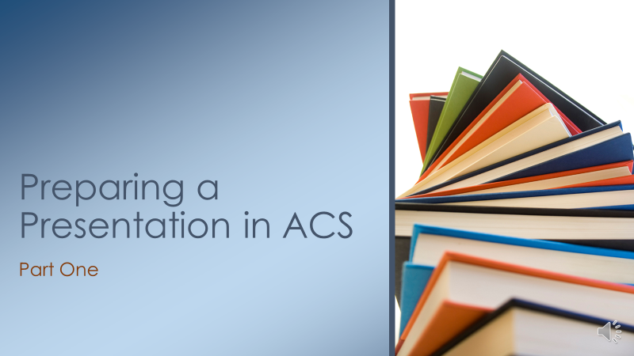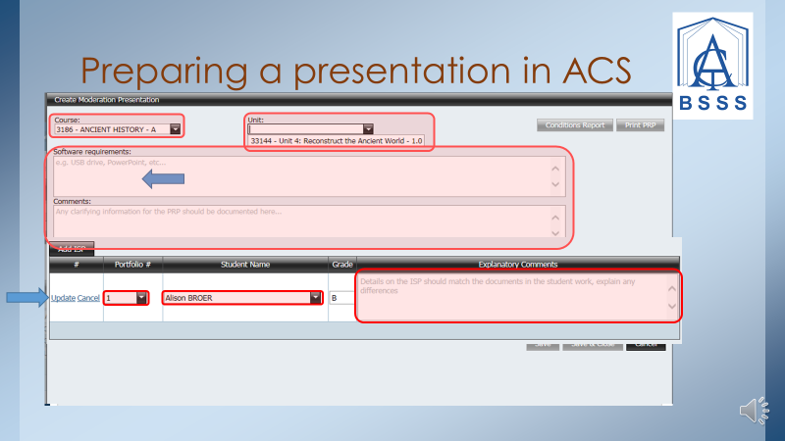

Creating a Presentation and Individual Student Profile form (ISP)

To begin preparing your presentation, click the Create Presentation button on the Moderation Presentation screen. Once in the Create Presentation screen, you'll need to select the correct course and unit from the drop-down menus. If you cannot see the correct course, it has not been added to your mark book. See your certification officer.
Next, add any details about the course including software requirements, or any clarifying comments such as an explanation for why you are not submitting an A or a C. Be sure to complete this section as it is not possible to add details later.
To create an Individual Student Profile form, or ISP, click the Add ISP button. Select the correct portfolio number and student from the drop-down menus and add any comments specific to the student in the Explanatory Comments box. When you have finished adding information for a student, click the Update button to save and move on.
The Create Presentation screen is also the place where you can download the ISPs.

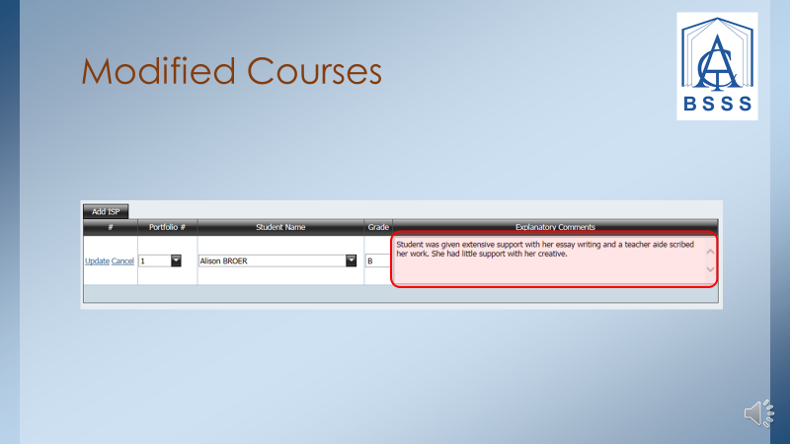

Modified Courses
If you are preparing a presentation for a Modified course, an Explanatory Comment is mandatory. This should only detail the amount of support a student received. There is no need to give personal details about the student or their ILP as this is confidential and not relevant for moderation purposes.

